Abstract

Presentation skills are always the first impression of your work and could either leave it well received and appreciated or underrated and more prone to being dismissed, hence they need to be as reliable and confident as possible. In our project, we are trying to create a platform that is easily available in which the presenter could practice their presentation skills and receive the necessary feedback to work on their weak points.

Our project consists of a virtual scene of a hall containing some characters that can react to the user’s speech, either by asking questions regarding said speech, reacting to the clarity of speech by making satisfied or dissatisfied facial expressions.

Our objective is mainly achieved by using NLP methods to understand the user’s speech and constructing questions that are relevant to the presenter's speech, and animating the characters to either react appropriately to the given speech or by asking relevant questions, hopefully making the user experience most aspects of a real presentation and finding a way to react appropriately to situations.

Motivation

After dealing with different situations and aspects in life, we found that presentation skills were essential to achieving most goals, whether it a new idea, a new job, a graduation project. Many people have exceptional ideas that may not make it through due to bad presentation of the idea. Due to this we decided to do a survey to find out how many people actually needed presentation skills and the difficulties that people face in presentations and talking in public and the results of the survey are as follow.

**The Survey Results:**

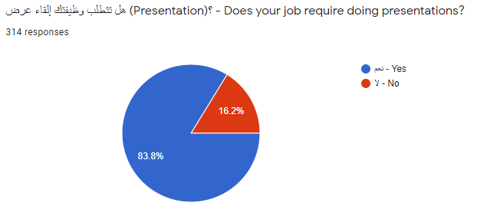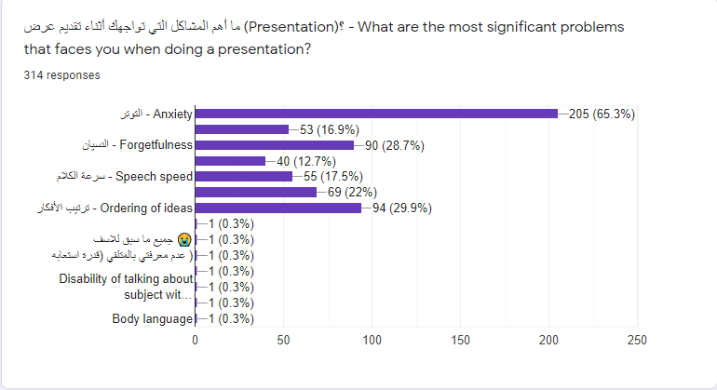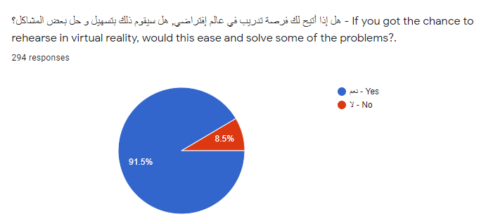

According to the responses we got, we found that 83.8% of people’s jobs required doing presentations. We also inquired about the challenges faced and 65.3% had anxiety issues, 29.9% with ordering of ideas, 28.7% dealt with forgetfulness, 22% with distractions, 17.5% with speech speed, 16.9 with not finding a place to practice, 12.7% can’t finish at specified time.

Also we found that 91.5% of responders would find it helpful if they were offered a virtual platform to practice their presentation beforehand.

After studying the responses, we found that the best way to get over these issues is by providing something that can help people practice easily and give them the feedback they needed to gain confidence and work on their errors.

**Introduction**

Our project is a VR platform that can help in solving the problems that most people face during giving a presentation by allowing them to practice on their own and get the feedback they need to improve their presentation.

The project is mainly a scene consisting of a hall filled with characters that react to the presentation using facial expressions or ask questions relevant to the presentation. The rate of speed of the presenter’s speech is also calculated and displayed in the hall to help him find a pace that is clear and informative.

The project consists of mainly five phases, Speech-To-Text, NLP, Question Generation, Text-To-Speech and Graphics.

The presenter starts the application and starts giving the presentation, here the speech-to-text phase starts and doesn’t end unless the presentation ends, for speech-to-text phase we use Google’s API, where the speech the presenter gives is converted to text in real-time. The words are counted and the speech's rate is calculated over intervals of time, and the feedback of the performance is updated each interval as a test in the hall and also the characters make facial expressions to reflect if they are satisfied with the rate or if it's too slow or too fast, to train the user how to deal with momentary disapproval.

The text we extracted from the speech is passed every interval of time to a model called the UniLM using an API that performs the NLP and Question Generation phases. The model analyzes the text and understands the context and generates relevant questions as an output. The questions generated are then returned from the API to the application.

Every interval of time, a question is chosen from the questions generated from the model and the text-to-speech phase starts where we pass the text to Google’s Text-to-Speech API, that returns an audio file of the question.

We choose a character randomly to voice the question and an appropriate voice is chosen to reflect the gender of the character and the character raises its hand to grab the presenter's attention and asks the question. Here the user is trained on being interrupted, and how to return to the same point he left in the presentation.

The graphics phase is in progress in parallel with all other phases as the scene is created in the graphics phase, the feedback of the rate of speech is animated over the facial expressions of the characters so here is was integrated with the speech to text phase. The characters are also animated to move and raise their hands and ask the question so here the graphics phase was integrated with the text-to speech phase.